This text records steps to create skeleton source code for application "QuestionImporter" for Sakai 11 (http://sakaiproject.org)

Step 1. Prepare tools
- Java: JDK 1.8 or later
- NetBean 8.1 or Eclipse 4.3
- Maven 3.3.1 (Install by execute command with root permission: yum install maven)

Step 2. Prepare to generate code for project
1. Create the folder for project. Ex: ~/QuestionImporter/SourceCode
2. From terminal, change the current directory to folder of project. Then execute below command:
mvn archetype:generate -DarchetypeGroupId=org.sakaiproject.maven-archetype -DarchetypeArtifactId=sakai-spring-maven-archetype -DarchetypeVersion=1.2 -DarchetypeRepository=https://source.sakaiproject.org/maven2/

(Refer: https://confluence.sakaiproject.org/display/BOOT/Sakai+Spring+MVC+Maven+Archetype)

Fill data for questions:
Define value for property 'groupId': : m.k.s.sakai.app
Define value for property 'artifactId': : question-importer
Define value for property 'version': 1.0-SNAPSHOT: : 0.1
Define value for property 'package': m.k.s.sakai.app: : m.k.s.sakai.app.question

Step 3. Configure to compile and deploy the application to sakai 11.1
-----------------------------------------
1.Modify “question-importer\pom.xml”
Line | Old source | To be updated
8 | <name>sakai-spring-maven-archetype</name> | <name>question-importer</name>
14 | <parent>  <groupId>org.sakaiproject.purepoms</groupId>  <artifactId>sakai-standard-tool</artifactId>  <version>2.8.4</version>  </parent> | <parent>  <groupId>org.sakaiproject.purepoms</groupId>  <artifactId>sakai-standard-tool</artifactId>  <version>2.8.7</version>  </parent>
38 | <dependency>  <groupId>org.projectlombok</groupId>  <artifactId>lombok</artifactId>  <version>0.11.0</version>  <type>jar</type>  <scope>provided</scope>  </dependency> | <dependency>  <groupId>org.projectlombok</groupId>  <artifactId>lombok</artifactId>  <version>1.16.10</version>  <type>jar</type>  <scope>provided</scope>  </dependency>
45 | <dependency>  <groupId>log4j</groupId>  <artifactId>log4j</artifactId>  <version>1.2.14</version>  </dependency> | <dependency>  <groupId>log4j</groupId>  <artifactId>log4j</artifactId>  <version>1.2.17</version>  </dependency>
50 | <properties>  <project.build.sourceEncoding>UTF-8</project.build.sourceEncoding>  </properties> | <properties>  <sakai.kernel.version>11.1</sakai.kernel.version>  <project.build.sourceEncoding>UTF-8</project.build.sourceEncoding>  </properties>

2. Modify “/question-importer/tool/src/main/webapp/WEB-INF/web.xml”

Line | Old source | To be updated
17 | <dependency>  <groupId>org.springframework</groupId>  <artifactId>spring</artifactId>  </dependency> | <dependency>  <groupId>org.springframework</groupId>  <artifactId>spring-core</artifactId>  </dependency>
46 | <listener>  <listener-class>org.sakaiproject.util.ContextLoaderListener</listener-class>  </listener> | <listener>  <listener-class>org.sakaiproject.util.SakaiContextLoaderListener</listener-class>  </listener>

Step 5. Compile and deploy to sakai
1) Change the current directory to the home of project. Then execute below command:
mvn -Dmaven.tomcat.home=<HOME OF SAKAI> install sakai:deploy
Ex:
mvn -Dmaven.tomcat.home=/home/lengocthach/jPackagesA/sakai11.1-tomcat-8.5.4 clean install sakai:deploy
2) Copy “$YOUR_HOME_DIRECTORY/.m2/repository/org/projectlombok/lombok/1.16.10/lombok-1.16.10.jar” into $SAKAI_TOMCAT/lib
3) Copy “…/question-importer/api/target/question-importer-api-0.1.jar” into $SAKAI_TOMCAT/lib

Step 5. Run sakai to view the tools
Now you can start the sakai, add tool “My Sakai App question-importer-tool” to a site by tool “Site info” to view the result as below:
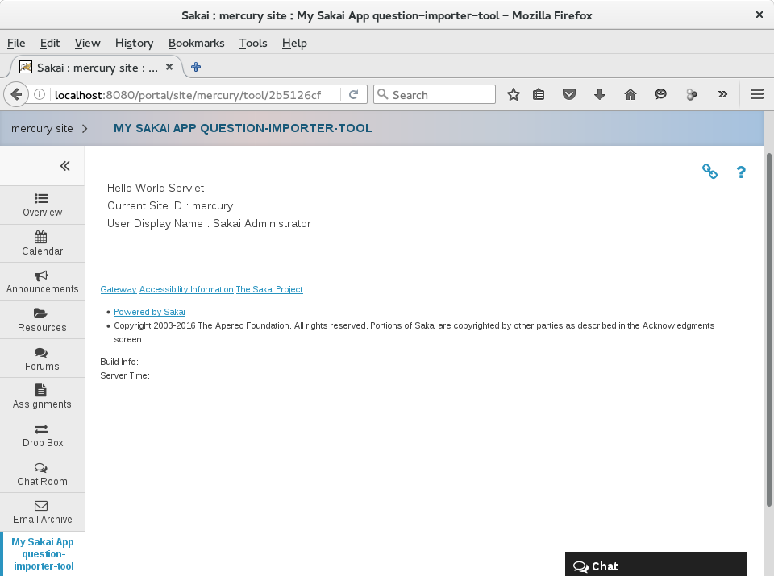

Step 6: Change name of the application
Modify “/question-importer-tool/src/main/webapp/tools/sakai.sakai-spring-maven-archetype.xml”
<?xml version="1.0"?>
<registration>
<tool id="sakai.question-importer"
title="My Sakai App question-importer-tool"
description="This description is set in the question-importer-tool registration file, found in the webapp/tools directory">

…
Then compile and deploy by the above step 4.

